

IT203

Signifi Email Signature Setup

|  |  |
| --- | --- |
| Status | Final |
| Version | 1.02 |
| Classification | Confidential |
| Owner | Razvan Anghelidi, Directory of IT |
| Address | 1705 Tech Avenue, Unit 3, Mississauga, ON, L4W 0A2, Canada |

*Statement of Confidentiality: This document and supporting materials contain confidential and proprietary business information of Signifi Solutions Inc. These materials may be printed or photocopied for use internally and must not be shared with other parties.*

Document Control iii

Email Stationery Setup Instructions 4

Compliance 9

Enforcement 9

Update 9

Revision History 9

All rights reserved

No part of this document may be reproduced in any form, including photocopying or transmission electronically to any computer, without prior written consent of Signifi Solutions (from now on, Signifi). The information contained in this document is proprietary to Signifi and may not be used or disclosed except as expressly authorized in writing by Signifi.

Trademarks

Other product names mentioned in this document may be trademarks or registered trademarks of their respective companies and are hereby acknowledged.

Document Control

The electronic version of this document is recognized as the only valid version.

Approval History

|  |  |  |
| --- | --- | --- |
| APPROVER(S) | TITLE/DEPARTMENT | APPROVED DATE |
| Shamira Jaffer | CEO | December 23rd, 2021 |
| Shamira Jaffer | CEO | December 7th, 2020 |
| Shamira Jaffer | CEO | June 17th, 2020 |
|  |  |  |
|  |  |  |

Document Sensitivity Level

Confidential

Email Stationery Setup Instructions

Overview

This document aims to assist employees to setup their email signatures to ensure a consistent brand throughout the organization. Please follow the instructions to ensure that your signature is correctly applied.

Example

THIS IS AN EXAMPLE TO ALLOW YOU TO CHECK YOUR FORMATTING BEFORE YOU COPY THE TABLE (please personalize on the next page)

|  |  |
| --- | --- |
|  | **Shamira** Jaffer CEO, President **CA**, US, FR, UK, DE, CH, AT, SE, NO, FI, DK Automated Retail + Asset Management + Loss Prevention  **e.** [sjaffer@signifi.com](mailto:sjaffer@signifi.com) **m.** +1-416-618-3454 **t.** +1-905-602-7707 **w.** signifi.com  3- 1703 Tech Ave, Mississauga, Ontario, CA, L4W 0A2  [Title: LinkedIn - Description: image of LinkedIn icon](https://www.linkedin.com/company/123141) [Title: Twitter - Description: image of Twitter icon](https://twitter.com/teamsignifi) |

Your signature

Update the table with your personal details here:

|  |  |
| --- | --- |
|  | **Shamira** Jaffer CEO, President **CA**, US, FR, UK, DE, CH, AT, SE, NO, FI, DK Automated Retail + Asset Management + Loss Prevention  **e.** [sjaffer@signifi.com](mailto:sjaffer@signifi.com) **m.** +1-416-618-3454 **t.** +1-905-602-7707 **w.** signifi.com  3- 1703 Tech Ave, Mississauga, Ontario, CA, L4W 0A2  [Title: LinkedIn - Description: image of LinkedIn icon](https://www.linkedin.com/company/123141) [Title: Twitter - Description: image of Twitter icon](https://twitter.com/teamsignifi) |

How to

**Step1:**  
Windows has the uncanny ability to change fonts where they don’t need to. Once you’ve updated your details, select the entire table and change the font to **CALIBRI.** It’s a system font so it should display on all emails.   
  
- Your name should be bold  
- Your surname should not be bold  
- To change your Country of where you operate, please select the short code, make it bold and change the color to our red (RGB: 227, G: 45, B: 73)  
- A easy way to get rid of the red, bold **CA** is to just add a CA after US and delete the **CA**, then move the CA back to the front – sorry no easy way here.

Copy the entire table by moussing over it selecting the square block in the right hand corner. Its extremely important that you do this step correctly. Then, right click and select **COPY.**.  
  
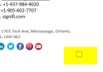

**STEP 2:**  
OPEN OUTLOOK

1. Select **New Email**  
     
   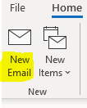
2. Select **Signature** at the top navigation panel:  
     
   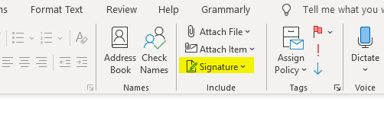
3. Then select **New:**  
   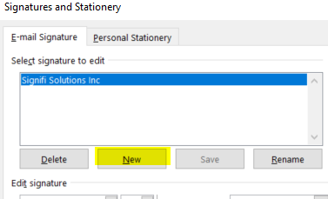
4. Type in a **Name** for your signature:

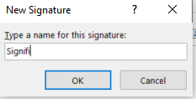

1. And **paste** your personal signature here. NOTE: This table is extremely sensitive and will break if you try to edit details here. Please ensure that ALL your changes are done in this document before you try to move your information over to Outlook
2. Then select where you want to display your signature: **New Messages** and/or **Replies/Forwards**. You can select both, only **New messages** option is advised.

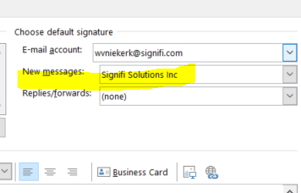

1. Click OK, close the pop-up box and create your first email. Your stationery will be applied.
2. Any issues please go back to **STEP 1.** Additionally, you can ask IT to assist [it@signifi.com](mailto:it@signifi.com).

Compliance

This policy will be officially monitored for compliance by the IT department director and may include random and scheduled inspections.

Enforcement

All instances of non-compliance will be reviewed by the department director. The department director, with the assistance of the Human Resources department has the authority to impose disciplinary actions, up to and including termination of employment or contractual agreement.

Update

This policy and all supporting documentation will be reviewed and updated annually or upon material changes to Signifi business rules, technology processes, organizational goals, or information security objectives to ensure its continuing suitability, adequacy, and effectiveness.

Revision History

|  |  |  |  |
| --- | --- | --- | --- |
| VERSION | DATE | SUMMARY OF CHANGE | CHANGED BY |
| 1.0 | 2020-06-17 | First Document | Shamira Jaffer |
| 1.01 | 2020-12-02 | Annual review | Razvan Anghelidi |
| 1.02 | 2021-01-21 | Changed the wording around the “Signifi application” | Razvan Anghelidi |
| 1.03 | 2021-12-12 | Annual review | Hadeel Alzuhairi |